**Outlier Discussion:**

Some counties with high fast food restaurant counts and low populations

Major highway counties

Really tiny counties (Kalawao County Hawaii) with low population, but also no fast-food

**Correlation check:**

1. Fast Food Restaurants and Full Service Restaurant have a correlation 0.6911
2. Percent Unemployed and Poverty rate 0.623
3. Fitness and Fast Food 0.65
4. Median Income and Poverty Rate -0.7474
5. Grocery Stores and Fast Food per 1000 is 0.25
6. Fitness and Poverty 0.2
7. Grocery and Full Service 0.49
8. Fitness and Full Service 0.544
9. Percent Unemployed and Median Income -0.42

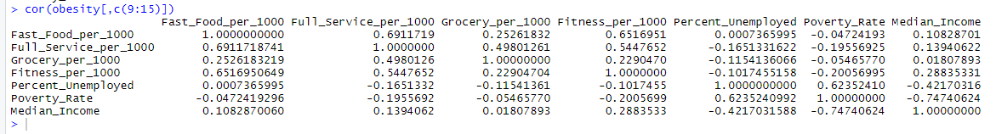

**Assumptions:**

1. Stability over time: Population and food patterns mostly stay constant over the year. Barring any sweeping policy changes, there won’t be much difference.
2. Complete census sample. There may be some people that aren’t captured by the census, but this is as close to a population data set as possible.
3. Normality check:

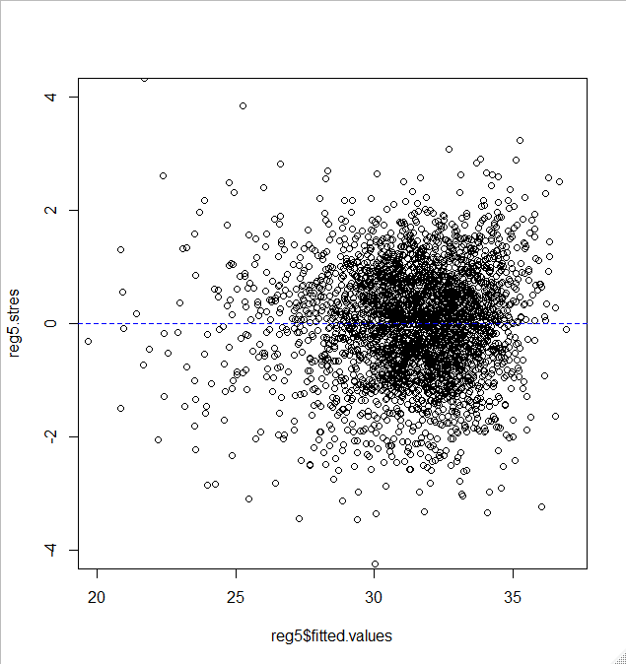

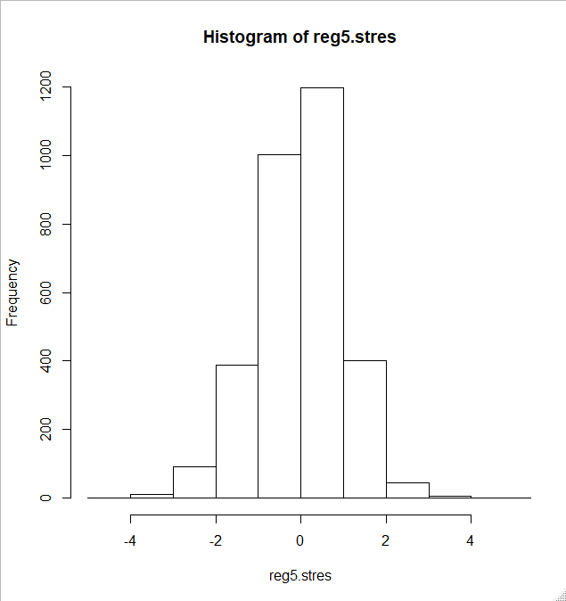

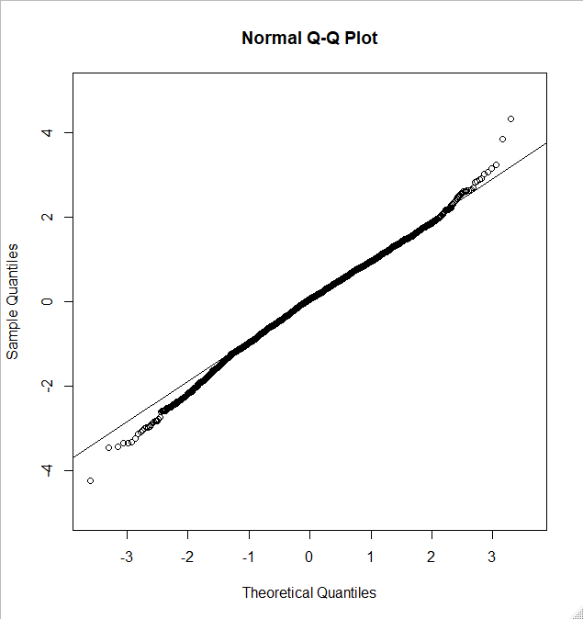

**(Selecting Trump’s Wives):**

* Remove Percent Unemployed as it contains a p-value of 0.38
* Remove Poverty as it contains a p-value of 0.38 and is correlated highly with median income
* Remove fitness
* Grocery

|  |  |  |  |  |
| --- | --- | --- | --- | --- |
| **Predictors** | **k** | **R2** | **s** | **Highest p-value** |
| List out predictors | 7 | .28 | 3.95 | .384 (percent unemployed) |
| List out predictors | 6 | .2798 | 3.949 | .374 (Poverty_Rate) |
| List out predictors | 5 | .2797 | 3.949 | .1931 (fitness) |
| List out predictors | 4 | .2793 | 3.95 | .0979(grocery) |
| List out predictors | 3 | .2786 | 3.951 | 0.00539 (fast food) |
| List of predictors | 2 | .2175 | 4.114 | 2e-16() |